Brief overview of special Excel formatting
Cell A1 should be ‘Room:’ and then the program will distinguish items in the same row as rooms
Times start from A2 and go downwards. They should have a colon in the middle (e.g. 08:30) so Excel recognises them as times
Key (This can all be customised – these are just some example categories with arbitrary colouring):
Names of speakers should be enclosed in <> e.g. <Sample Speaker>
[b] = event for everyone (e.g. registration or lunch break). These go in the B column next to the corresponding time. When the code parses these, it will stretch the event to span across all the rooms
e.g.
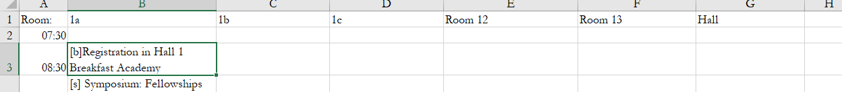

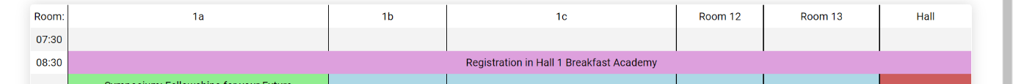
produces:
[s] = Symposium event. These are highlighted green
[p] = Short papers session. These are highlighted blue
[v] = Exhibition. These are highlighted red
[e] = Education session. These are highlighted orange
[r] = Royal college lecture. These are highlighted purple

